Aim : Create Camera Shake Effect in Unity.

Step 1 : Open the Unity app → select new project → write the project name → select the template (3D )→ click on create project

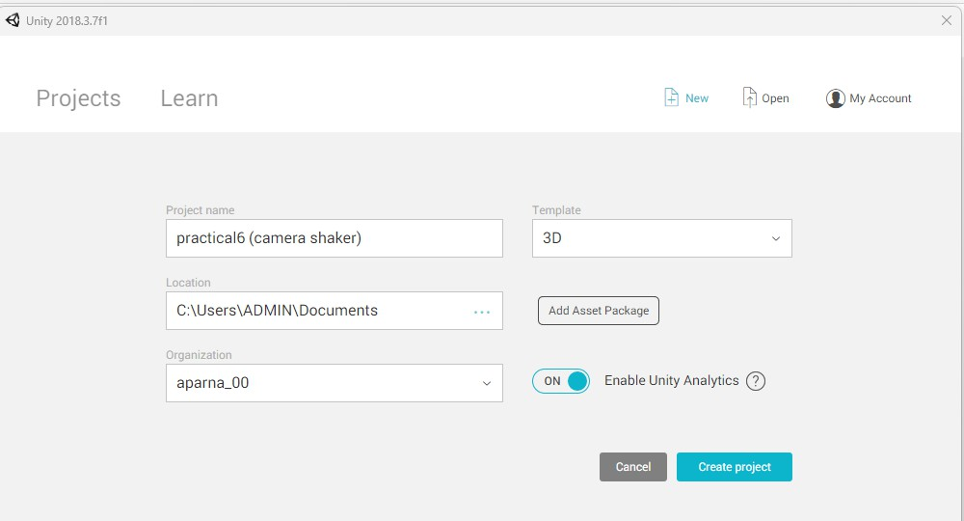

Step 2 : We are going to create a miniatureto observe the shaking of a camera. (Miniatures will consist of a sphere , cube , etc ).

Add the Gameobject by clicking on the GameObject → 3D Object → sphere.

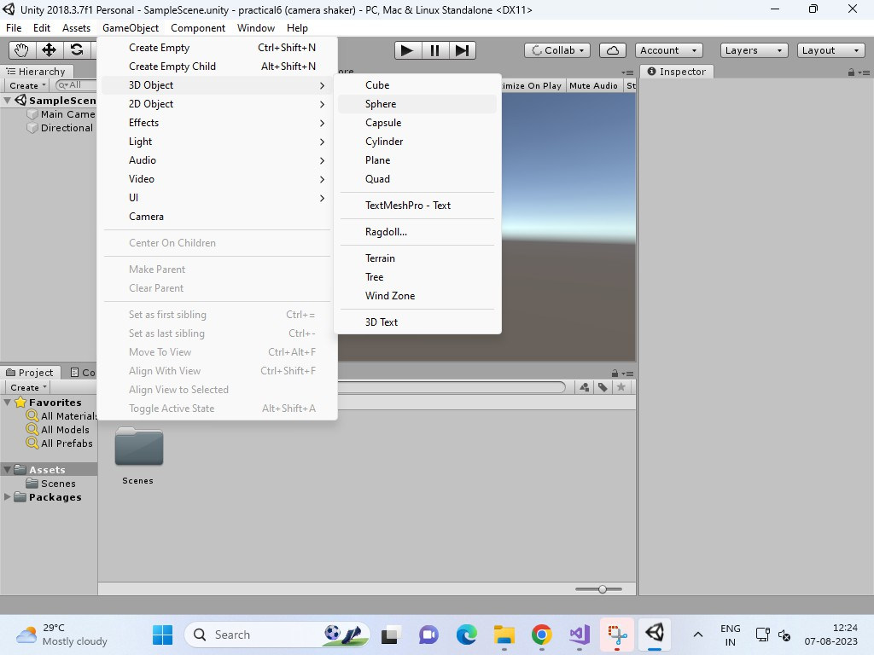

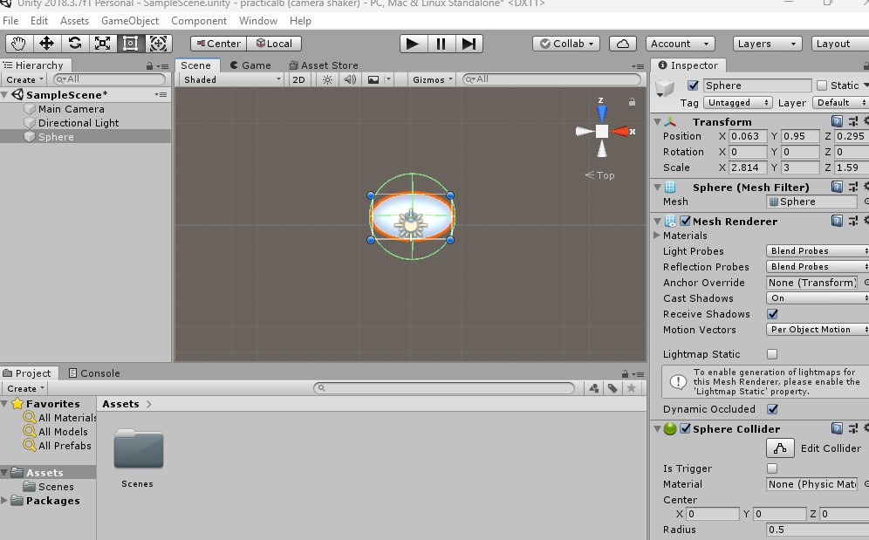

Step 3: Add the Gameobject by clicking on the GameObject → 3D Object → cube

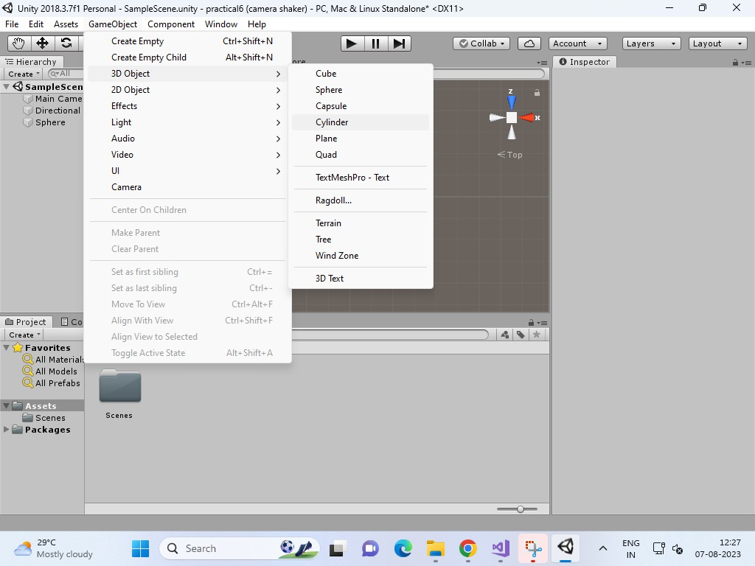

Step 3: All the GameObject will be seen in the Hierarchy window.

Make the changes in the properties according to your need. Properties of the GameObject will be visible in the Inspector window.

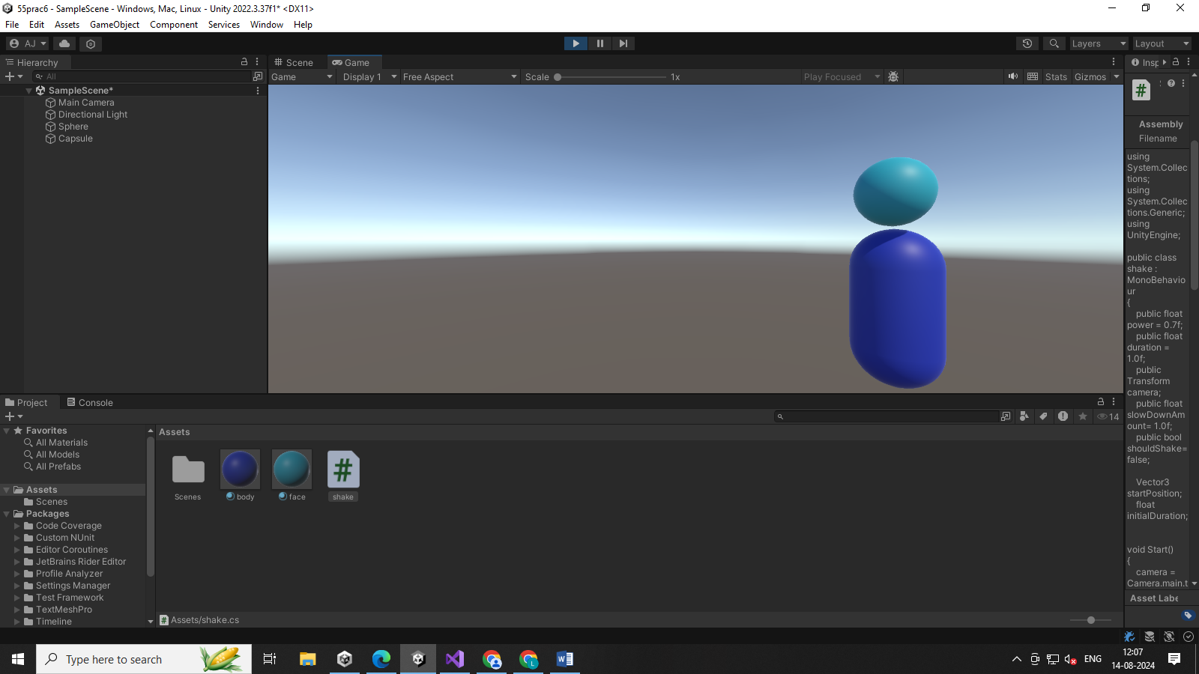

Step 4: If you want to change the color of the GameObject, Create the material from the Asset window.

Name it as color and change the properties or select the color according to your choice.

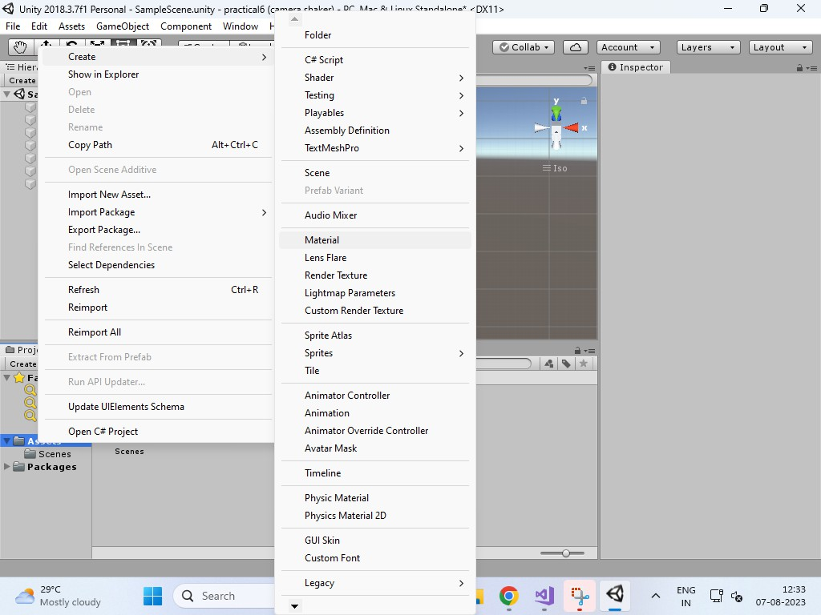

Step 5 : Properties → changes in the inspector window → click in unit —> select color —>abele

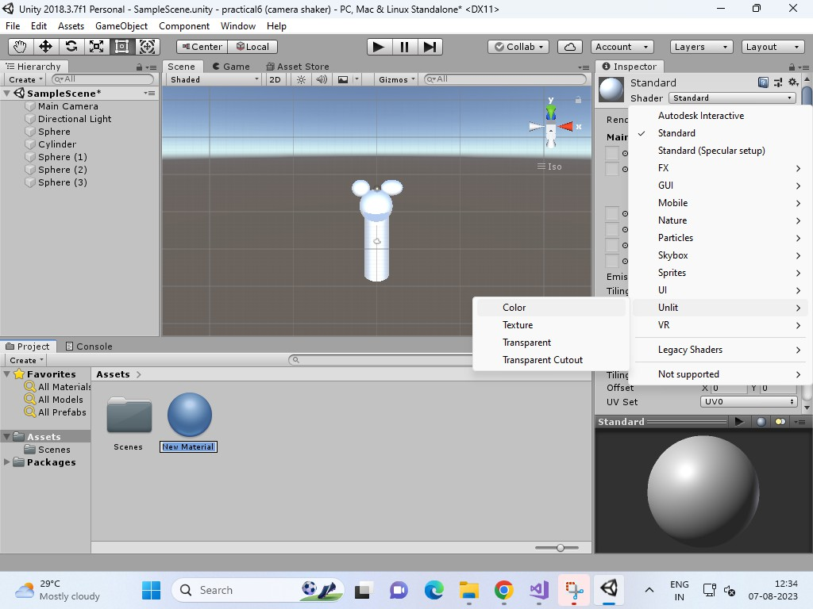

Select the color from the hex.

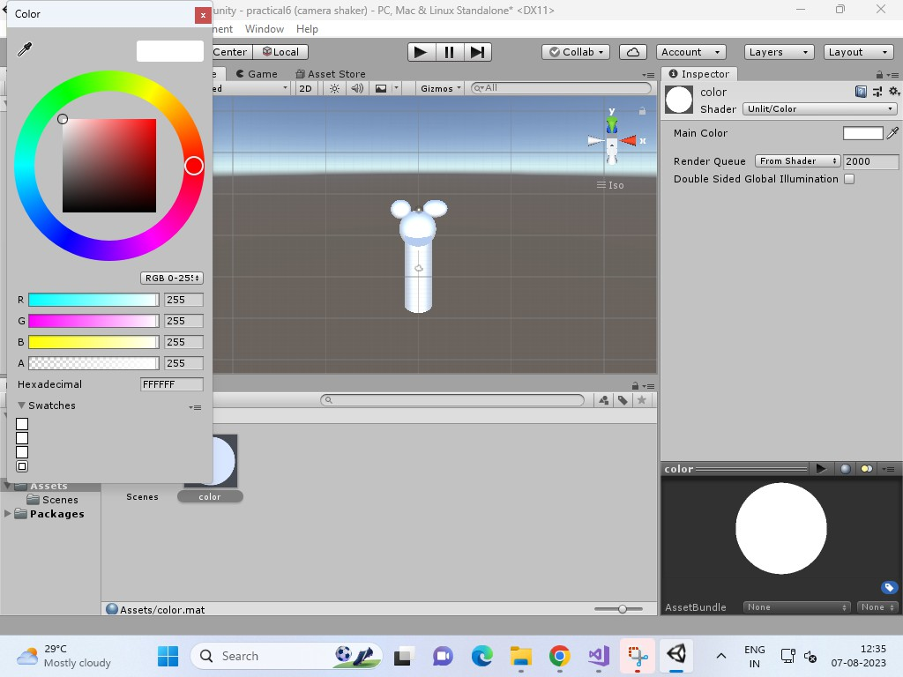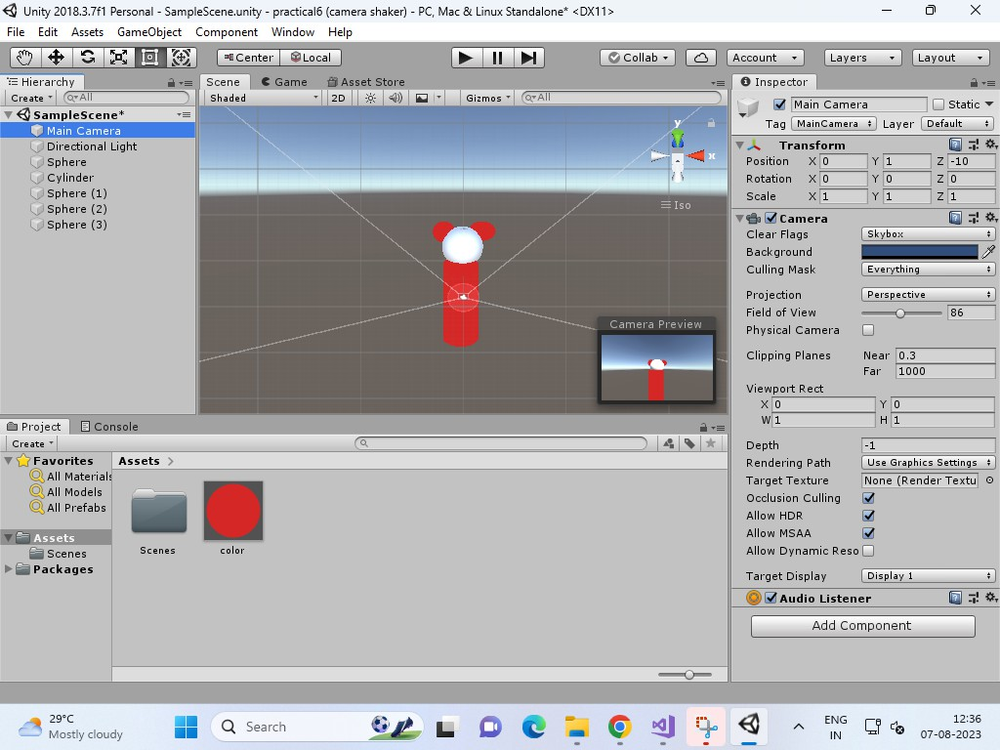

Step 6: check whether the camera is adjust properly and light is there or not on the object that you have created.

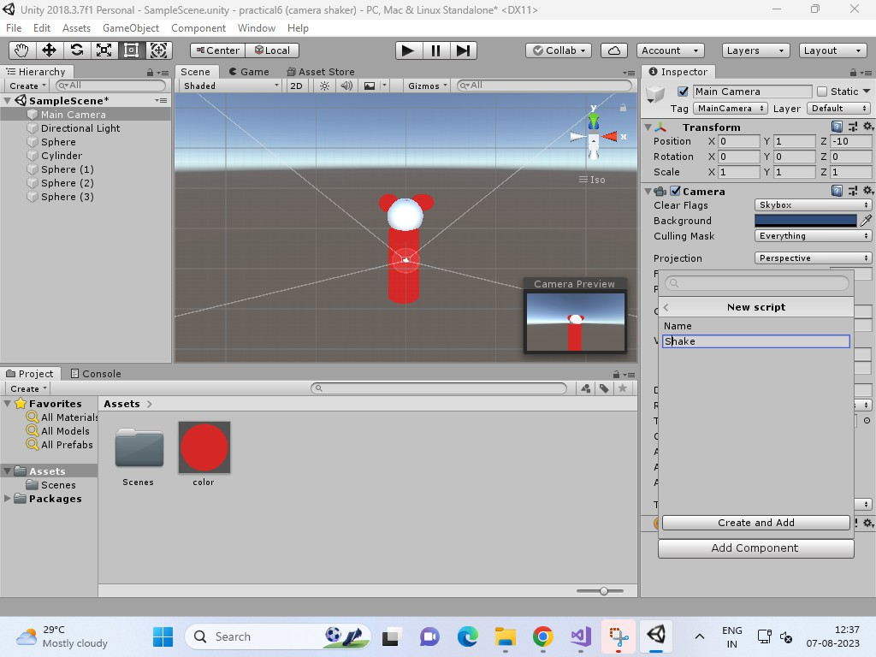

Step 7 : Once everything is done we have to make the camera shake for that write the C# script.

For C# script → click on main camera ( in hierarchy window ) —> Go to inspector window ( make the changes in the properties) i.e Add Component → click on script → add new script → name it —> script file will be visible in the asset window → double click on it.

Visual studio will open → write the code.

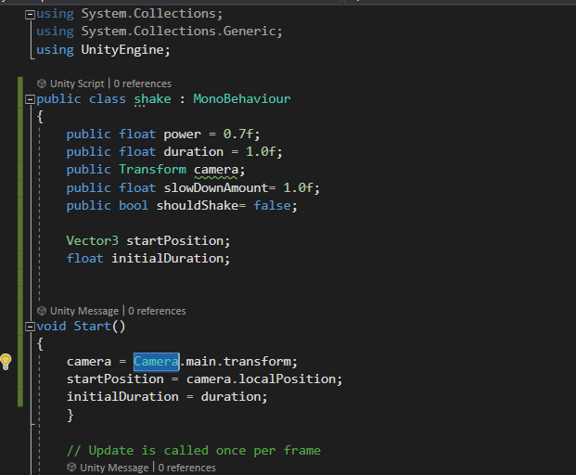

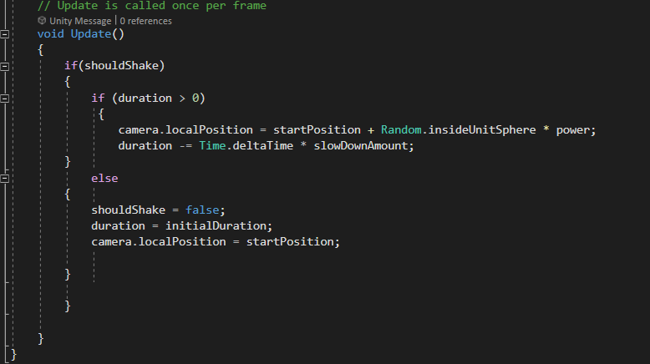

using System.Collections;

using System.Collections.Generic; using UnityEngine;

public class shake : MonoBehaviour

{

public float power = 0.7f; public float duration = 1.0f;

public Transform cameraTransform; public float slowDownAmount = 1.0f; Vector3 startPosition;

public bool Shake = false; float initialDuration;

// Start is called before the first frame update void Start()

{

cameraTransform = Camera.main.transform; startPosition = cameraTransform.localPosition; initialDuration = duration;

}

// Update is called once per frame void Update()

{

if (Shake)

{

if (duration > 0)

{

cameraTransform.localPosition = startPosition + Random.insideUnitSphere \* power; duration -= Time.deltaTime \* slowDownAmount;

}

else

{

Shake = false;

duration = initialDuration; cameraTransform.localPosition = startPosition;

}

}

}

public void StartShake()

{

Shake = true;

}

}

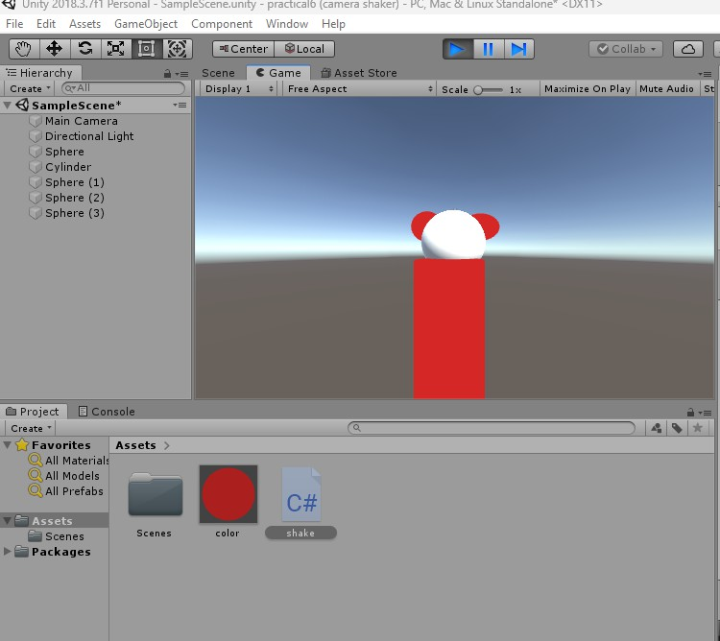Step 8: Once it is done , go to unity —> play the game —> you will find the variable of the script. Click on the shake variable to shake the camera.

